**Ideation Phase**

**Brainstorm & Idea Prioritization Template**

|  |  |
| --- | --- |
| Date | 22 September 2022 |
| Team ID | PNT2022TMID31901 |
| Project Name | Estimate The Crop Yield Using Data Analytics |
| Maximum Marks | 4 Marks |

**Brainstorm & Idea Prioritization Template:**

Reference: <https://app.mural.co/invitation/mural/naalaiyathiran1419/1663768779938?sender=u8d8fa718a17bacc9f02b4633&key=c0680266-19ad-4cb1-9f82-2d2ea0537724>

**Step-1: Team Gathering, Collaboration and Select the Problem Statement**

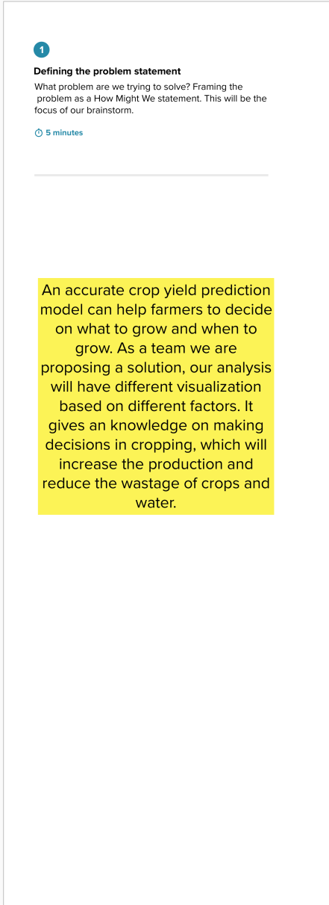

**Step-2: Brainstorm, Idea Listing and Grouping**

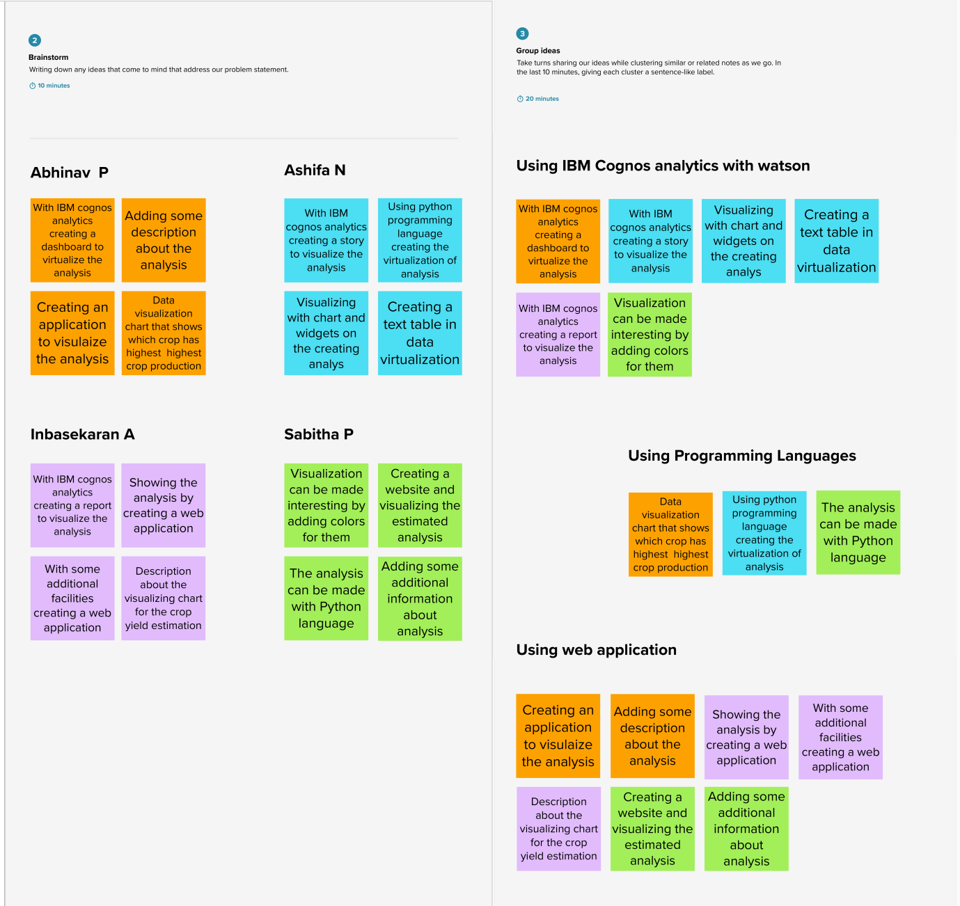

**Step-3: Idea Prioritization**

